

Wind load Analysis for Rolling Shutter
as per Indian Standards IS 875 Part III 1987

1 | 0 | Project: | SUSTEN
1 | 0 | Client: | MAHINDRA SUSTEN
1 | 0 | Date: | 08/11/2017
1 | 0 | Height: | 5000 mm
1 | 0 | Width: | 5000 mm
2 | 0 | Slat Size: | 75 mm
2 | 0 | Slat Width: | 15 mm
2 | 0

Wind Load Analysis as per IS

Design Wind Speed Vz= Vb * k1 * k2 * k3
where Vb = Basic Wind Speed in m / s. | = | 25 m/s
k1 = Risk Coefficient (clause 5.) | = | 1
k2 = THS Factor (clause 5.3 | = | 1
k3 = Topography Factor (clause 5.) | = | 1
Vz = Design Wind Speed | = | 25 m/s

Terrain Category: 2
(Open terrain with well-scattered obstructions having heights between 1.5m to 10m)

Class of Building: A (Structures having max. dimensions is less then 20m)

k1, k2 & k3 constants are derived from IS-875, based on location height of
structure & geographical factor. These factors are required for tall structures,
Where we need to consider varying pressure condition.

Wind Load Analysis as per IS 875 - III

Design wind pressure Where,
= | 2  0.6 x V_{z}

Pz = Design wind pressure
Vz = Design wind velocity

Wind Pressure, Pz | = 0.6 x (25)2
Wind Pressure, Pz | = | 375 N/m^2
Pz | = | 0.000375 N/mm^2

Wind Load Analysis as per IS 875 - III

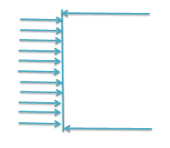
Assumed - Simply supported beam with uniform pressure.

375 N/m^2

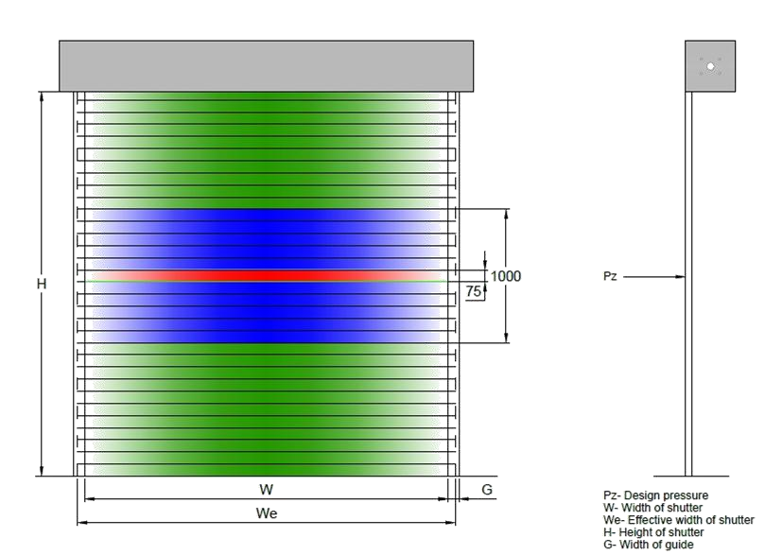

Contents: A)Bending Moment B)Deflection C)Maximum Stress
D)Side guides for curtain

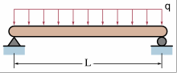
A) Bending Moment

Door is simply supported on two opposite sides
Max B.M. M = α x W x L²/8
Where, W= UDL load
α= Bending moment coefficient as per IS 456:2000-Table26
B) Deflection
Max. deflection will be at the Centre of slat
D max = (5 X M X L^2) / (48 x E x I)

Where,
M = Bending Moment of Slat
E = Modules of Elasticity for CRS = 210GPa (KN/mm2)
I = Moment of Inertia of slat (From CAD Data)
L = Clear width of Shutter

C)Max Stress

Max. Stress= M x ȳ/ I
Where,
M=Bending moment of slat, ȳ= dist. of side on y-y from CG, I= moment of inertia,
Permissible Stress =248/FOS
=248/1.5
= 165 N/sq.mm

D)Side Guides for Curtain panel
Side Guides required = w/60
Where,
w= width of shutter

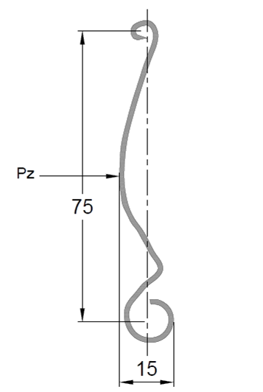
1. Wind Analysis for rolling shutter of size 5000mm(w) x 5000mm(h)

Design Wind Speed Vz= Vb * k1 * k2 * k3
where,
Vb = Basic Wind Speed in m / s.
k1 = Risk Coefficient (clause 5.4.1)
k2 = THS Factor (clause 5.3.2)
k3 = Topography Factor (clause 5.3.3)
Vz = Design wind Speed

= | 25
= | 1
= | 1
= | 1
= | 25 m/s

Design wind pressure = 0.6x 25x25= 375 N/m2
UDL acting on Slat, W = Pz x A/L |  | Where, A= Area of slat
= | 0.000375 x (5000 x 75) / 5000
W = | 0.0281 N/mm
Bending Moment M = α. (W x L²)/8
= | 0.056 x 0.0281 x 5000 x 5000 / 8
= | 4917.50 N-mm

Ø Assuming thickness of slat 1 mm & minimum height as 75mm & depth as 15mm.
(From CAD DATA)
I= | 1564 mm^4

E= modulus of elasticity for CRS= 210 GPA
= 210000 N/mm^2
Max. deflection |  | = | 5 x 4917.5 x 5000 x 5000 / (48 x 210000 x 1564)
 |  | = | 38.99 mm
Permissible deflection = 5000/150 |  |  |  |  | Note - As max. stress is less than permissible stress, hence no permanent deformation of slat will occur.
As per IS:800 |  |  | = | 33.333 mm
Max. stress | = | 4917.5x15/(2x1564)
 | = | 23.58 N/mm^2
Permissible stress = (248 N/mm2) /1.5
 |  | = | 165 N/mm^2

Guide side required = 5000/60 = 83.33
we are using 150mm guide.

Wind Load Analysis for different size shutter

SR NO | SHUTTER SIZE  WXH in mm | WIND SPEED | WIND LOAD IN N/m2 | ALLOWABLE  DEFLECTION  IN mm | ALLOWABLE  MAX.STRESS  IN N/mm2 | DEFLECTION IN  SHUTTER | MAX.STRESS  IN SHUTTER  IN N/mm2
1 | 3000X3000mm | 25m/s | 375 N/m2 | 20mm | 165 N/mm2 | 5.05mm | 8.49 N/mm2
2 | 3000X4000mm | 25m/s | 375 N/m2 | 20mm | 165 N/mm2 | 5.05mm | 8.49 N/mm2
3 | 4000X4000mm | 25m/s | 375 N/m2 | 26.66mm | 165 N/mm2 | 15.97mm | 15.09 N/mm2
4 | 5000X5000mm | 25m/s | 375 N/m2 | 33.33mm | 165 N/mm2 | 38.99mm | 23.58 N/mm2

